**Name : أحمد رئيف كمال سعد سالم**

**B.N: 60**

**Topic:** **Operating Systems**

**Github link :** [**https://github.com/AhmedElesily/ECE001-**](https://github.com/AhmedElesily/ECE001-)

**Github page :** [**https://ahmedelesily.github.io/ECE001-/**](https://ahmedelesily.github.io/ECE001-/)

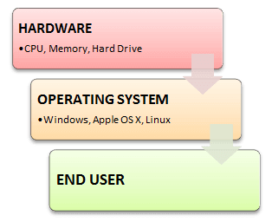**Introduction:** An **Operating system (OS)** is a software which acts as an interface between the end user and computer hardware. Every computer must have at least one OS to run other programs. An application like Chrome, MS Word, Games,etc needs some environment in which it will run and perform its task. The OS helps you to communicate with the computer without knowing how to speak the computer's language. It is **not** possible for the user to use any computer or mobile device without having an operating system.

**Summary**

* An operating system is a software which acts as an interface between the end user and computer hardware
* Operating systems were first developed in the late 1950s to manage tape storage
* The kernel is the central component of a computer operating systems. The only job performed by the kernel is to the manage the communication between the software and the hardware
* Two most popular kernels are Monolithic and MicroKernels
* Process, Device, File, I/O, Secondary-Storage, Memory management are various functions of an Operating System
* Batch, Multitasking/Time Sharing, Multiprocessing, Real Time, Distributed, Network, Mobile are various types of Operating Systems

**Screenshots :**

